Real Estate Amber

Software Product Perspective

Demo

Contents

About Real Estate Amber 3

User types and hierarchy 3

User types 3

Hierarchy of User privileges 3

User Stories 3

1. Login & Create Account Page 3

2. Home Page 4

4. Settings Pages 5

Software Development Life Cycle 5

Software Development Process 6

Context Diagram 7

Quality Attributes for REA 7

Conflict between Quality Attributes 8

Architecture 8

Definition of Done 8

Table 1 - Quality Attributes 7

Figure 1 - Context Diagram Alpha Version 7

# About Real Estate Amber

Real Estate Amber (REA) is a new web platform designed to allow a fast and reliable means to search for, and sell, private properties, regardless of their size and price. Its modern design, along with the innovative technologies used, make Real Estate Amber website a sound choice for buying and selling your properties. And it is very easy to use ! All you need to do is to make an account, which shouldn’t take more than a minute to complete. Then you simply have to post your property, along with a few details, and you are done !

Amber, dedicated to finding you your dream home !

# User types and hierarchy

## User types

1. Guest : a visitor of the web page without an account or who is not currently logged in. Can navigate the web pages and check Properties for sale. However, no input events are accepted from them until logged in.
2. User : a visitor of the web page currently logged in. Can post content and input events are accepted. Most common type of user.
3. Admin : administrator with greater privileges than an average user. Can manage content and when needed, interact with and modify other user’s content, or deactivate them if absolutely necessary.

Hierarchy of User privileges

Guest < User < Admin

If a User type of lower privilege has access to a functionality, then all other higher ranking User types will also have access to it.

# User Stories

## 1. Login & Create Account Page

1. I, as a User, need a login page, in order to access my account. The Login page should ask for my email, name and password, and should have a button in case my password no longer works or I have forgotten it.
2. I, as a User, need a service which allows me to reset my password in the event I no longer remember it or it has been changed against my will. This service should ask for my email address, which then sends a link to my email address which once clicked, will take me to a page where I can insert a new password, along with a password confirmation.
3. I, as a Guest, require a page to create my account, in order to better interact with REA. This page should ask for my email, name, password, and password confirmation.
4. I, as a Guest, require a means to activate my account once it is made, in order to access my account and to prevent the creation of dummy accounts as easily. There should be a service which sends an activation link to the email I set to my account, which once clicked, takes me to the login page and my account is now active.

## 2. Home Page

1. I, as a User, need a home profile button in order to return to my timeline page, to make it easier to view my profile with minimum navigation. This button should be located on a dynamic position in the top of the page.
2. I as a Guest, need a search bar, in order to search for property posts. The search bar should accepts the name, type, price, range, and location as input and generate results as the input is placed. Should be on a dynamic position in the top of the page.
3. I, as a User, require a menu button where I can navigate to pages required for technical reasons such as Sell Property, Settings, Help and Log Out, in order to easily navigate to them when needed. This button should be on a dynamic position in the top of the page.
4. I, as a User, require a notifications button which displays the number of notifications received since last checked, in order to be aware of any changes to my posts, if anyone has messaged me on my posts, or if there are any posts that match my preferences. This button should be in a dynamic position in the top of the page.
5. I, as a User, need a button in the menu panel to get me to the Settings page, in order to update my profile fast and easy.
6. I, as a Guest, require a page displaying the post’s details, in order to better check the details of a property sale, along with contact information from the user who posted.
7. I, as a User, require a button to create a new post, in order to facilitate the creation of new content, and to advertise my sale. This button should be visible, and located on my panel on the right dropdown of the web page.
8. I, as a User, need a section of the web page dedicated for posts, in the middle column, made of all post panels, starting from the most recent, in order for me and any other Users or Guests to view existing content.
9. I, as a User, require each of my post panels to include a details describing the post, and one or more images. Each post should be clickable and take me to a page with more details of the post. In addition, at the bottom of the post page, there should be a comment section. The Comment section should offer the possibility to post a comment, which the user should be notified of.

## 4. Settings Pages

1. I, as a User, require pages and links to them where I can update various elements within my account, such as my display name, email, phone nr, password, in order to manage the different technical aspects of my account as I need easily.
2. I, as a User, require a Settings button in the menu options which links me to my account settings page, where I can edit my account.
3. I, as a User, require that on the Account page, there should be a middle panel with details regarding my account, such as name, email, location, as well as buttons for updating my Email and password, and deactivating my Account.
4. I, as a User, require that the Email button open a panel, where I can update my email address, should there ever be a need to. The panel should contain an input field with the new email, confirmation of the new email, and a verification code received via the current email address, in order to prevent account theft and in order to avoid accidentally setting the wrong email. There should be a notification when the new email has been set.
5. I, as a User, require that the Account deactivation button open a panel, where I can deactivate my account, should there ever be a need to. The panel should contain a button which when clicked sends a verification code to the current email address of the account, an input field for the verification code, and a confirmation button. These are needed in order to avoid accidentally deactivating the account.
6. I, as a User, need a Help page where I can search for questions or problems regarding my account, in order to easily find a solution. The page should contain a search bar where I can search for key words regarding my issue, a list of commonly asked questions, and a contact info for teach support (preferably an email and or phone number).
7. I, as a User, need a Notifications page where I can toggle notifications settings for my web page, my mobile app and my email, for my posts, as well as search preferences. This is needed in order to set the types of notifications I want based on the platform I am using.
8. I, as a User, require a Timeline page where I can interact with my posts in order to manage my content. Interactions with my posts include commenting.

# Software Development Life Cycle

Agile software development describes an approach to software development based on close collaboration between organized, cross-functional teams and the different stakeholders involved, for requirements and solutions to be created and gradually evolved. It supports adaptive planning, evolutionary development, short iterations for early deliveries and continuous improvements. It emphasizes the need to be flexible and open to changes, since that is often the case in real life scenarios.

Agile development essentially has four core values [2]:

1. Individuals and interactions over process and tools
2. Working software over extensive documentation
3. Customer collaboration over contract negotiation
4. Responding to change over following a plan

Thanks to the values promoted by agile development, several methodologies have surfaced. Each of these methodologies is different in the types of projects they specialize, the terminologies used, the artefacts they are focused on, what approach they focus on, and how interactions between the stakeholders take place. The most popular of these at the moment are:

1. Scrum
2. Extreme Programming (XP)
3. Rational Unified Process
4. Dynamic System Development Method
5. Feature Driven Development
6. Spiral Lifecycle Model

Considering the limitations at hand, both from the project, as well as the desired tool to be produced, it was determined that the SCRUM approach is most suited for the task at hand. The reasons for this are as follows.

From the team’s perspective, SCRUM seemed like a natural choice, given the Design Driven Development was also chosen. SCRUM also helps us in verifying our work on a regular basis, while also creating a structure within the team.

# Software Development Process

The development process chosen for REA is Domain Driven Development (DDD). The reason for this lies in the nature of the project and the product vision the CEO had. Since the design and feature aspects involve insurance that all information is displayed, is correct, and it ensures easy display and communication with the users, DDD would be the best practice.

From the CEO’s point of view, DDD helps break down the vision, and help search for alternatives.

# Context Diagram

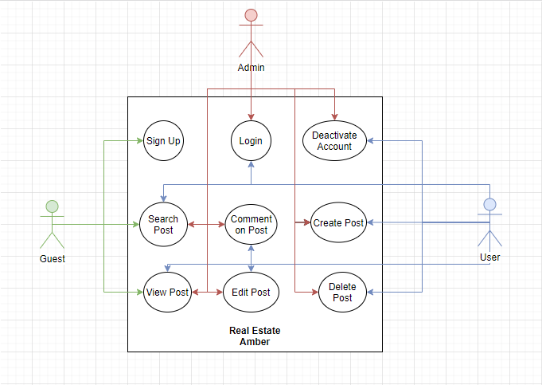

Figure - Context Diagram Alpha Version

Guest = a visitor of the web page without an account or who is not currently logged in.

User = a visitor of the web page currently logged in.

Admin = administrator with greater privileges than an average user.

# Quality Attributes for REA

|  |  |  |  |
| --- | --- | --- | --- |
| Priority | Attribute | Justification | Conflict |
| 1 | Real-Time | Show Posts and Notifications as soon as they occur | YES (Big Data) |
| 2 | Maintainability | REA must be open to changes in the form of future additions, updates, and evolutions | NO |
| 3 | Big Data | It is vital to handle big data for persistency and in order to avoid the decrease of quality of the service | NO |
| 4 | Security | User Data must be protected and secured in order to ensure trust and reliability, and avoid the information being accessed by unwanted parties | NO |
| 5 | Backup | Backup for User Profile Data, History and Content should the servers suffer unforeseen or unwanted events | Yes (Big Data) |

Table - Quality Attributes

Priority : 1 is High, 5 is Low

## Conflict between Quality Attributes

Backup & Big Data : Backup of huge amounts of data will be hard and will increase costs

Real-Time & Big Data : Real-Time information from huge data bases will be challenging

# Architecture

See document “REA Software Architecture”.

# Definition of Done

1. Requirements for the intended software product are gathered and organized in the form of User Stories.
2. An architecture of the Software Product is made.
3. A design for the Software Product is Established and agreed upon.
4. Developers write code for all User Stories.
5. Designers design pages for all User Stories.
6. Testing will be done for each iteration, where the code is executed and working successfully.
7. Performance and Acceptance tests are passed.
8. Documentation updated and completed.
9. Remaining tasks are 0 and are closed.